Land Use

4.1 Introduction to Land Use
Developing a quality land use data set to meet the needs of the Phase 5 Model was a challenging element of the Phase 5 development. Phase 5 required a consistent data set for the entire Phase 5 Model domain, a domain covering an area of eight states including Maryland, Delaware, and Virginia, in their entirety. Further, the land use estimates needed to change annually over the 1985 to 2005 simulation period. Compounding the difficulty was the need to have corresponding data sets of estimated manure and fertilizer inputs. The best available data sets providing a consistent level of accuracy throughout the Phase 5 domain were integrated to produce a final Phase 5 Model land use, with an emphasis on accuracy in the developed (urban, suburban, rural) and agricultural areas.

The Phase 5 model expands land uses to 24 types, including 11 types of cropland, 2 types of woodland, 3 types of pasture, 5 types of developed land, and provisions for other special land uses such as surface mines and animal feeding operations. The nutrients in the major land uses of woodland, cropland, hay, pasture and pervious urban are simulated using the AGCHEM modules within HSPF that fully simulate forest or crop nutrient cycling, including uptake by plants. The minor pervious land uses, which are harvested forest, land under construction, nurseries, surface mines, and degraded riparian pasture are simulated through PQUAL which represents nutrient export through concentration coefficients.. Impervious land uses are simulated through the IQUAL modules, which use accumulation and washoff coefficients to simulate nutrient and sediment export. Each AGCHEM land use is simulated on an hourly time step tracing the fate and transport of input nutrient loads from atmospheric deposition, fertilizers, animal manure, and point sources. Each land use is simulated as a single acre in each segment, and this single acre is then multiplied by the acres of each land use draining to each river-segment.

We used the best available relevant databases that would provide us with a consistent estimate of land use throughout the Phase 5 Model domain. The principal databases were the 2000 land cover data developed by the University of Maryland’s Regional Earth Science Applications Center (RESAC) (Goetz et al. 2004), the 1992 National Land Cover Dataset (NLCD) covering the southern rivers portion of the study area (i.e., North Carolina and Tennessee) (USGS 1992), the agricultural census data on a county level (U.S. Census Bureau 1982, 1987, 1992, 1997, 2002) used for agricultural land and animal populations, and GIS road network overlays (Tele Atlas 2004). Ancillary data were also collected for land uses such as bare-construction and extractive-active and abandoned mines land uses. Note: When referring to a specific Phase 5 land use, this report uses italics for the land use name.
Land use is dynamic and changing annually throughout the Phase 5 domain. Annual land use data were estimated by interpolating land use/land cover in 1990 and 2000 from the RESAC and NLCD maps and the annual data from these years to the agricultural census years of 1982, 1987, 1992, 1997, and 2002 (U.S. Census Bureau 1982, 1987, 1992, 1997, 2002) (Figure 4.1). The final Phase 5 land use is available as a subcounty tabular database for the years 1982, 1987, 1990, 1992, 1997, 2000, 2002 and also is available for every year in the 1985 to 2005 simulation period by further interpolation. The annual Phase 5 subcounty tabular data sets of land use are available in the Phase 5 Model Data Library at: http://ccmp.chesapeake.org/CCMP/models/CBPhase5/datalibrary.php.

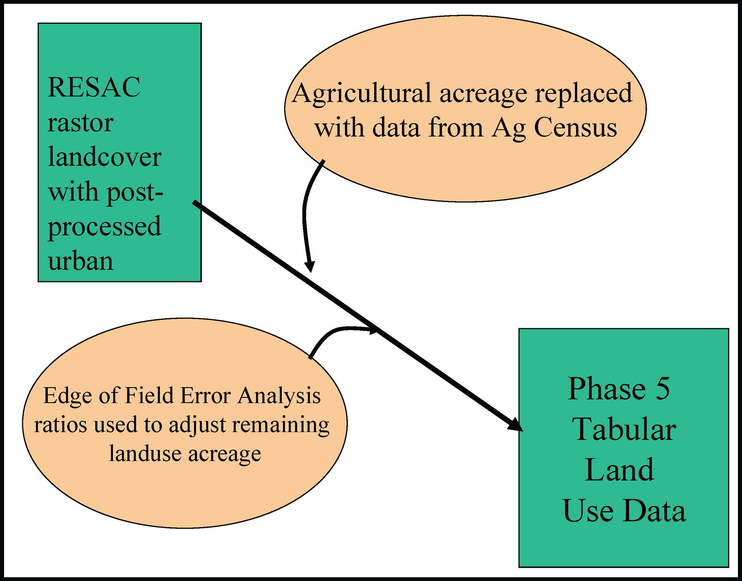
Figure 4.1. General schematic of the data flow associated with the development of land use data estimates.

At the time of the Phase 5 model calibration, a temporally consistent land cover database representing the Phase 5 study area was unavailable. Therefore, a 30-meter-resolution land cover database was pieced together using the best available data, which included the 2000 land cover data developed by the University of Maryland’s RESAC, and the 1992 NLCD covering the southern rivers portion of the study area. The following discussion outlines the major steps taken to develop a 2000 land cover data set for all Phase 5 land-river segments.

4.2 Generating Developed Pervious and Imperious Land Use Data

4.2.1 Developing a 30m Land Cover Data Set for the P5 Study Area
The University of Maryland’s RESAC mapped 2000 land cover and 2000 and 1990 impervious surfaces using Landsat 7-ETM and Landsat 5-TM imagery for all Landsat scenes intersecting the Bay watershed. Additionally, RESAC produced 2000 land cover and impervious surface data for the remaining lands in Virginia that fall to the south and west of the Bay watershed. These data sets are described in previously published documents (Goetz et al. 2004) and generally follow the USGS protocol used to develop the 2000 NLCD (Homer et al. 2002; Homer et al. 2004). One of the major deviations from the USGS protocol, however, involved using road density and town boundary data, which were available for the 2000 period only, to define developed tree and grass classes. Incorporating urban trees and grasses into the low-medium intensity developed class improved the user’s accuracy from approximately 15 to over 60 percent and the producer’s accuracy from approximately 9 to over 80 percent. Urban trees and grasses are lands that have the spectral appearance of trees or grasses and fall within town boundaries or areas with high road densities. Unfortunately, these processing steps also resulted in some commission errors (e.g., classifying lands adjacent to divided highways and within cloverleaf interchanges as urban trees and classifying all forest lands within town/municipal boundaries as urban trees). To correct for the errors associated with highways, a highway data set was developed from 1998 GDT Dynamap 1000 road data (Tele Atlas 2004). Highways include federal, state, and county primary roads and access ramps. All urban tree areas within 60 meters of a highway and lacking any underlying impervious surfaces were reclassified back to forests. All forest and wetland classes within 60 meters of a highway with underlying impervious surfaces were reclassified to low-intensity developed. Finally, to ensure consistency in mapping high-intensity developed areas over time, all low-intensity developed pixels with greater than 50 percent underlying impervious surfaces were reclassified as high-intensity developed.
For the southern rivers region, the 1992 NLCD data for North Carolina and Tennessee were merged together and reclassified into 10 Phase 5 land cover classes. To update the total urban and developed extent of the 1992 NLCD data to the year 2000, a map of housing density was used to mimic the total extent of developed areas. The final Phase 5 land cover classification is outlined in Table 4.1.
Table 4.1. Phase 5 land cover classification compared to 1992 LNCD and 2000 RESAC classifications.
P5 Land Cover Classes | 1992 NLCD Classes  (for NC and TN) | 2000 RESAC Classes
1 Open water (Water) | Open water (11) | Open water (1)
2 Low-intensity developed  (LowInt_Urb) | Low-intensity developed (21) and all Barren, Transitional, Forest, Agricultural, or Recreational grasses classes within the housing density threshold | Low-intensity developed (3), urban trees/grasses (10–15), and forests and wetlands adjacent to highways with underlying impervious surfaces.
3 Extractive (Extract) | Extractive (32) | Extractive (17)
(see Sec 4.5.1) | Bare and transitional (31, 33) | Barren (18)
5 Deciduous forest  (DecidF) | Deciduous forests and Woody wetlands (41, 91) | Deciduous forests and wetlands (20, 35) and urban deciduous trees adjacent to highways with no underlying impervious surfaces.
6 Evergreen forest  (EvergF) | Evergreen forest (42) | Evergreen forests and wetlands (21, 36) and urban evergreen trees adjacent to highways with no underlying impervious surfaces.
7 Mixed forest  (MixedF) | Mixed forest and Emergent wetlands (43, 92) | Mixed forests and wetlands (22, 38) and emergent wetlands (37) and urban mixed trees adjacent to highways with no underlying impervious surfaces.
8 Agriculture | Agriculture (81–84) | Pasture (25) and Cropland (26)
10 High-intensity developed  (HighInt_Urb) | Medium/ High-intensity developed (22, 23) | Medium/High-intensity developed and Transportation (4, 5, 8) and all pixels meeting criteria for the P5 Low-intensity developed class with underlying impervious surfaces > 50%.
No Data | N/A | No Data (0)

4.2.2 Mapping High- and Low-Intensity Development in 2000
The Phase 5 domain was divided into three zones on the basis of data availability (Figure 4.2). Zone 1 includes the Phase 5 study area north of Landsat row 35 and east of Landsat path 18. Zone 2 encompasses southern and southwestern Virginia in Landsat row 35 and Landsat path 18 (including the overlapping portion of Landsat scene 17:34). Zone 3 encompasses the Tennessee and North Carolina portions of the study area. Data availability is greatest in Zone 1 and least in Zone 3. Data available for Zone 1 include the 1990 NLCD, RESAC Land Cover for 1990, 2000 Impervious Cover, and 1990 and 2000 Census Population and Housing Census. Data available for Zone 2 include all the above except the 1990 Impervious Cover. Only the 1990 NLCD and the 1990 and 2000 census data are available for Zone 3.
The high-intensity developed class from the Phase 5 land cover data set was used to represent high-intensity developed lands for the year 2000 in Zones 1 and 2. In Zone 3, this class was derived directly from the 1992 NLCD and, therefore, does not represent conditions in 2000. During the 1990s, impervious and associated pervious surfaces within high-intensity developed areas increased by 61.4 percent in southern Virginia. However, impervious surface change tends to overestimate the rate of change, so an average of the change in housing and change of impervious values was used as a multiplier to simulate

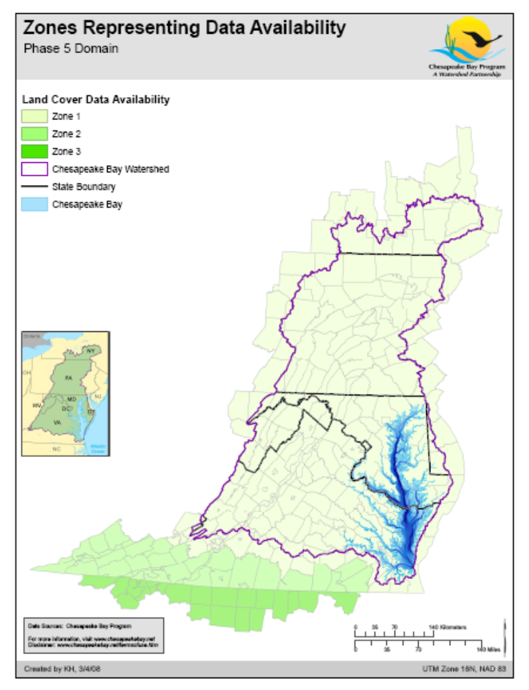
Figure 4.2. Zones representing data availability in the Phase 5 domain.

the probable level of high-intensity developed area for the year 2000 in Zone 3. When no single-detached housing units existed in a land-river segment in Zone 3, only the impervious change multiplier of 1.629 (1/0.614) was used.
The low-intensity developed class from the Phase 5 land cover data set was used to represent low-intensity developed lands for the year 2000 in Zones 1 and 2. In Zone 3, this class was derived by subtracting the simulated increase in high-intensity developed lands from the total amount of developed lands in the Phase 5 land cover data set. Thus, it was assumed in Zone 3 that increases in high-intensity developed lands would occur in areas that were simulated to be low-intensity developed in the Phase 5 land cover data set.

4.2.3 Mapping High- and Low-Intensity Developed Areas in 1990
High-intensity developed lands in 1990 were simulated in all zones using a variety of reduction factors on the basis of measured changes in single-detached housing units or measured changes in impervious cover between 1990 and 2000. In Zone 1, the reduction factor was a weighted average of the change in single-detached housing units (×2) and the change in impervious surface area from 1990 to 2000. The change in single-detached housing units was included twice to weight their influence more heavily given the tendency of the impervious surface data to overestimate change. In Zones 2 and 3, the reduction factor was a weighted average of the change in single-detached housing units (×2) and 0.614 (representing the average change in impervious surfaces in southern Virginia). If no impervious surfaces were present in a land-river segment in 1990, only the change in single-detached housing units was used as the reduction factor. If no single-detached housing units existed in a land-river segment or no change occurred in single-detached housing units, only the change in impervious area was used as the reduction factor. If no change in single-detached housing and either no change occurred in impervious area or no impervious area existed in a land-river segment, the developed extent was assumed to remain constant.
Low-intensity developed lands in 1990 were modeled on the basis of the linear relationship between single-detached housing units and low-intensity developed extent in 2000. To derive this linear relationship, single-detached housing units in 2000 (independent variable) were compared to the total low-intensity developed extent (dependent variable) for all land-river segments in Zones 1 and 2 using a linear regression model. The model showed a strong linear relationship (r² = 0.85, p-value < 0.001, Std. Err. = 921) between these variables. Six outliers, land-river modeling segments with more than 50,000 single-detached housing units, were excluded from the regression analysis. Excluding these outliers reduced the standard error by 10 percent and had only a minimal effect on the R² value (lowering it from 0.88 to 0.85). The residual error varied greatly for individual land-river segments. Therefore, the error in the estimated 2000 low-intensity developed extent was calculated for each land river segment and used to adjust the estimated 1990 low-intensity developed values. For example, one land-river segment might contain 10,000 acres of low-intensity developed area in the year 2000, but the regression model estimates that it contains only 8,000 acres. Using the regression model to estimate the 1990 low-intensity developed area in this land-river segment might lead to a similar underestimate. Therefore, the modeled 1990 value would be multiplied by 1.25 (1/0.8) to adjust for this error. This method of estimating low-intensity developed lands in 1990 was applied to all zones.

4.2.4 Estimating the Proportion of Impervious and Pervious Area
For each land-river segment, the impervious developed area was estimated by separately multiplying the mean percent impervious surface within high- and low-intensity developed areas by the total area of high- and low-intensity developed lands. Within Zone 1, the mean percent impervious surface was calculated directly from the 1990 and 2000 sub-pixel impervious surface data sets produced by RESAC. Within Zone 2, the mean percent impervious surface in 2000 was calculated directly from the sub-pixel impervious surface data set, while constant values of 17.05 and 4.74 percent were used to represent the 1990 mean percent impervious surface within high- and low-intensity developed areas, respectively. These values reflect the mean percent impervious surface within high- and low-intensity developed areas in the southern Virginia. In Zone 3, these same constant values were used to represent the mean percent impervious surface in 1990 and additional constant values (25.86 percent and 6.61 percent) were derived in southern Virginia to represent the mean percent impervious surface within high- and low-intensity developed areas in 2000.

4.2.5 Estimating the Amount of Adjustable Developed Land
The U.S. Census Bureau’s Census of Agriculture is the most accurate measure of total cropland and pasture within a county that’s available for the entire Phase 5 Model domain. Satellite-derived estimates of cropland and pasture have higher uncertainty in the prediction of the extent of these land cover classes compared to the Census of Agriculture in certain land-river segments, so the census was used for these important, high-nutrient and sediment-loading land uses. Accordingly, to accommodate the Census of Agriculture land use and land cover, the extent of developed and forest lands had to be adjusted at the Phase 5 land segment level. Area adjustments in developed areas were restricted to that portion of the low-intensity pervious class that was not directly associated with impervious surfaces (i.e., land cover pixels with zero percent impervious surfaces as measured from the sub-pixel impervious surface data sets). The rationale for this restriction was that this portion of low-intensity developed was predominately modeled on the basis of housing census data rather than directly measured from satellite imagery.
The adjustable percentages of low-intensity pervious developed lands in Zones 1 and 2 were estimated by calculating the proportion of low-intensity developed area associated with impervious surfaces to the total low-intensity developed area. In Zone 3, a constant value of 22.4 percent was calculated, representing the proportion of low-intensity developed area associated with impervious surfaces to the total low-intensity developed area in southern Virginia. These percentages were also used to estimate the adjustable portion of low-intensity pervious developed lands in 1990 for all zones. The elements applied in the development of the Phase 5 land use data are listed in Table 4.2.

4.3 Agricultural Land Use

4.3.1 Use of Census of Agriculture
Detailed, spatially consistent, time varying agricultural land use data are needed for the entire Phase 5 domain for model calibration. Approximately one-quarter of the land in the Phase 5 domain is agricultural, which has high input loads of fertilizers and manures, as well as periods of relatively low cover during planting and harvesting operations. The high nutrient inputs and periods of low cover have the potential for high nutrient and sediment export from agricultural land. Accuracy in the agricultural acreage is essential to appropriately simulate nutrient and sediment loads.
Data from the U.S. Census of Agriculture for the years 1982, 1987, 1992, 1997, and 2002 were used to augment RESAC agricultural acreage estimates. The agricultural census was used because it is the most complete agricultural survey available for the entire study area on a county scale, has a consistent spatial and temporal methodology, and is available every 5 years spanning the entire simulation period.

4.3.2 Agricultural Land Use Classification
Acreage of specific crops in the agricultural census are combined to form seven Phase 5 agricultural land uses. Census crops with similar surface cover characteristics and fertilizer application rates were grouped together and have similar nutrient loading properties. All agricultural acreage in the census is accounted for in the Phase 5 agricultural classes. Phase 5 agricultural classes include pasture, alfalfa, hay-unfertilized, hay-fertilized, degraded stream corridor, conventional tillage, conventional tillage with manure, and conservation tillage with manure. Table 4.3 summarizes the county-level land use data contained in the U.S. Census of Agriculture and the census table in which the data are found. In this report, names of cropland types estimated for the Phase 5 land use, and all Phase 5 land uses, are in italics.
Table 4.3. Agricultural land use data in U.S. Agricultural Census
U.S. Agricultural Census Table | U.S. Agricultural Census Data Category ª | Census Item Number
Table 6: Farms, Land in Farms | Total cropland | 060045
 | Cropland used only for pasture or grazing | 060049
 | Cropland on which all crops failed | 060055
 | Cropland in cultivated summer fallow | 060057
 | Cropland idle | 060059
 | Pastureland, all types | 060073
Table 26: Grains | Corn for grain or seed | 260002
 | Sorghum for grain or seed | 260007
 | Wheat for grain | 260012
 | Barley for grain | 260042
 | Buckwheat | 260047
 | Emmer and spelt | 260067
 | Oats for grain | 260082
 | Popcorn | 260087
 | Rye for grain | 260102
 | Sunflower seed | 260112
 | Triticale | 260117
Table 27: Cotton, Tobacco | Cotton | 270002
 | Tobacco | 270007
 | Soybeans | 270012
 | Dry edible beans | 270017
 | Potatoes, excluding sweet potatoes | 270042
 | Sweet potatoes | 270047
 | Peanuts for nuts | 270077
Table 28: Seeds, hay, forage, and silage | Hay-alfalfa, other tame, small grain, wild grass, silage, green chop, act. | 280127
 | Alfalfa hay | 280132
 | Wild hay | 280147
 | Corn for silage or green chop | 280157
 | Sorghum for silage or green chop | 280167
 | Sorghum cut for dry forage or hay | 280162
Table 29: Vegetables, sweet corn, and melons | Land used for vegetables | 290002
Table 30: Land in Orchards | Land in Orchards, total | 300002
Table 32: Berries harvested for sale | Berries | 320002
Table 33: Nursery and Greenhouse Crops | Nursery and greenhouse crops, acres in the open | 330003
Table 34: Other Crops | Corn cut for dry fodder, hogged, or grazed | 340002
 | Sorghum for syrup | 340082
 | Sorghum hogged or grazed | 340087
Note:
ª All data are in harvested acres.

How the different Agricultural Census crops aggregated into the Phase 5 land uses is summarized in Table 4.4 and outlined in more detail for each of the land use subsections below.
Table 4.3. Aggregation of U.S. Agricultural Census land uses into the Phase 5 land uses.
 |  | Nutrient
Crop | Landuse | Management | Tillage
alfalfa | alfalfa | N | NA
alfalfa | alfalfa nutrient management | Y | NA
barley | conventional tillage with manure | N | conventional
barley | conventional tillage with manure nutrient management | Y | conventional
barley | conservation tillage with manure nutrient management | Y | conservation
barley | conservation tillage with manure | N | conservation
berries | conventional tillage | N | conventional
berries | conventional tillage nutrient management | Y | conventional
buckwheat | conventional tillage with manure | N | conventional
buckwheat | conventional tillage with manure nutrient management | Y | conventional
buckwheat | conservation tillage with manure nutrient management | Y | conservation
buckwheat | conservation tillage with manure | N | conservation
corn dry fodder | conventional tillage with manure | N | conventional
corn dry fodder | conventional tillage with manure nutrient management | Y | conventional
corn dry fodder | conservation tillage with manure nutrient management | Y | conservation
corn dry fodder | conservation tillage with manure | N | conservation
corn grain | conventional tillage with manure | N | conventional
corn grain | conventional tillage with manure nutrient management | Y | conventional
corn grain | conservation tillage with manure nutrient management | Y | conservation
corn grain | conservation tillage with manure | N | conservation
corn silage | conventional tillage with manure | N | conventional
corn silage | conventional tillage with manure nutrient management | Y | conventional
corn silage | conservation tillage with manure nutrient management | Y | conservation
corn silage | conservation tillage with manure | N | conservation
cotton | conventional tillage | N | conventional
cotton | conventional tillage with manure nutrient management | Y | conventional
dry beans | conventional tillage with manure | N | conventional
dry beans | conventional tillage with manure nutrient management | Y | conventional
dry beans | conservation tillage with manure nutrient management | Y | conservation
dry beans | conservation tillage with manure | N | conservation
emmer spelt | conventional tillage with manure | N | conventional
emmer spelt | conventional tillage with manure nutrient management | Y | conventional
emmer spelt | conservation tillage with manure nutrient management | Y | conservation
emmer spelt | conservation tillage with manure | N | conservation
failed crops | hay-fertilized nutrient management | Y | NA
failed crops | hay-fertilized | N | NA
fallow land | hay-unfertilized | N | NA
idle land | hay-unfertilized | N | NA
nursery | nursery | N | NA
oats | conventional tillage with manure | N | conventional
oats | conventional tillage with manure nutrient management | Y | conventional
oats | conservation tillage with manure nutrient management | Y | conservation
oats | conservation tillage with manure | N | conservation
orchards | conventional tillage without manure | N | NA
pasture | pasture | N | NA
pasture | pasture nutrient management | Y | NA
peanuts | conventional tillage without manure | N | conventional
peanuts | conventional tillage w/o manure nutrient management | Y | conventional
popcorn | conventional tillage with manure | N | conventional
popcorn | conventional tillage with manure nutrient management | Y | conventional
popcorn | conservation tillage with manure nutrient management | Y | conservation
popcorn | conservation tillage with manure | N | conservation
rye | conventional tillage with manure | N | conventional
rye | conventional tillage with manure nutrient management | Y | conventional
rye | conservation tillage with manure nutrient management | Y | conservation
rye | conservation tillage with manure | N | Conservation
sorghum forage | conventional tillage with manure | N | Conventional
sorghum forage | conventional tillage with manure nutrient management | Y | Conventional
sorghum forage | conservation tillage with manure nutrient management | Y | Conservation
sorghum forage | conservation tillage with manure | N | Conservation
sorghum grain | conventional tillage with manure | N | Conventional
sorghum grain | conventional tillage with manure nutrient management | Y | Conventional
sorghum grain | conservation tillage with manure nutrient management | Y | Conservation
sorghum grain | conservation tillage with manure | N | Conservation
sorghum silage | conventional tillage with manure | N | Conventional
sorghum silage | conventional tillage with manure nutrient management | Y | Conventional
sorghum silage | conservation tillage with manure nutrient management | Y | Conservation
sorghum silage | conservation tillage with manure | N | conservation
soybeans | conventional tillage with manure | N | conventional
soybeans | conventional tillage with manure nutrient management | Y | conventional
soybeans | conservation tillage with manure nutrient management | Y | conservation
soybeans | conservation tillage with manure | N | conservation
sunflower | conventional tillage with manure | N | conventional
sunflower | conventional tillage with manure nutrient management | Y | conventional
sunflower | conservation tillage with manure nutrient management | Y | conservation
sunflower | conservation tillage with manure | N | conservation
sweet potatoes | conventional tillage without manure | N | conventional
sweet potatoes | conventional tillage w/o manure nutrient management | Y | conventional
tame hay | hay-fertilized nutrient management | Y | NA
tame hay | hay-fertilized | N | NA
tobacco | conventional tillage without manure | N | conventional
tobacco | conventional tillage w/o manure nutrient management | Y | conventional
triticale | conventional tillage with manure | N | conventional
triticale | conventional tillage with manure nutrient management | Y | conventional
triticale | conservation tillage with manure nutrient management | Y | conservation
triticale | conservation tillage with manure | N | conservation
vegetables | conventional tillage without manure | N | conventional
vegetables | conventional tillage w/o manure nutrient management | Y | conventional
wheat | conventional tillage with manure | N | conventional
wheat | conventional tillage with manure nutrient management | Y | conventional
wheat | conservation tillage with manure nutrient management | Y | conservation
wheat | conservation tillage with manure | N | conservation
white potatoes | conventional tillage without manure | N | conventional
white potatoes | conventional tillage nutrient management | Y | conventional
wild hay | hay-unfertilized | N | NA

4.3.2.1 Hay-Fertilized
Hay with nutrients includes all tame and small grain hay excluding wild hay or alfalfa, which are included in other categories. These crops receive fertilizer and have a high degree of surface cover for most of the year. Failed cropland is also included in this category because they receive fertilizer but are not harvested, a pattern most similar to hay-fertilized.
Hay-fertilized =
(Hay-alfalfa, other tame, small grain, wild grass, silage, green chop, act.) – (Wild hay) – (Alfalfa) + (Cropland on which all crops failed).

4.3.2.2 Hay-Unfertilized
The hay-unfertilized category includes hay or other herbaceous agricultural areas that do not receive fertilizer and are not harvested, such as wild hay, idle cropland, and fallow land.
Hay-unfertilized =
(Wild hay) + (Cropland idle) + (Cropland in cultivated summer fallow)

4.3.2.3 Alfalfa
This category contains only alfalfa hay. This is a dominant hay crop in many areas of the watershed. Alfalfa is a separate hay category because it is a nitrogen-fixing, leguminous crop and receives different nutrient applications than other hay crops.

4.3.2.4 Conventional or Conservation Tillage with Manure
The conventional tillage with manure and the conservation tillage with manure categories contain grain, corn, soybeans, and dry beans. Wheat, corn, and soybeans are the dominant crops in the Chesapeake watershed, often planted in a 2-year rotation on the same parcel of land. Crops in this category receive nutrient inputs from manure application as well as fertilizer. This is the highest percentage of cropland in the Chesapeake watershed. On average 90 percent of total cropland is estimated to be in this category.
Conventional tillage with manure and the conservation tillage with manure =
(Wheat for grain) + (Barley for grain) + (Buckwheat) + (Emmer and spelt ) + (Oats) + (Popcorn) + (Rye for grain) + (Sunflower) + (Triticale) + (Corn for grain) + (Corn for silage or green chop) + (Corn cut for dry fodder, hogged, or grazed) + (Sorghum for grain or seed) + (Sorghum for silage or green chop) + (Sorghum cut for dry forage or hay ) + (Sorghum for syrup) + (Sorghum hogged or grazed) + (Soybeans) + (Dry beans)
Information from the Conservation Technology Information Center (CTIC, 1989-2004) provides annual information by county of the splits between the conventional and conservation tillage acres for these two crop land uses. The CTIC National Crop Residue Management Survey lists the percent under conservation tillage for corn, small grain, soybeans, and sorghum on a county level for each year starting in 1989. The percent under conservation tillage for the composite crop is calculated as a weighted average of the individual crop percentages, using crop acreage as a weight. Tillage practices for 1989 are used for the agriculture census years 1982 and 1987.

4.3.2.5 Conventional Tillage without Manure
The conventional tillage without manure category contains cotton, tobacco, and vegetables. Because most of these crops are grown for direct human consumption, there is generally no manure application. These crops are simulated as only grown with a conventional tillage system. Orchards are also included in this category.
Conventional tillage without manure =
(Cotton) + (Tobacco) + (Land used for vegetables) + (Potatoes, excluding sweet potatoes) + (Sweet potatoes) + (Berries) + (Nursery acres in the open) + (Land in orchards)

4.3.2.6 Pasture
The pasture category contains only the pastureland item from the agricultural census. The Phase 5 simulated pasture does not receive fertilizer but can have higher nutrient input loading than hays or idle land because of manure from grazing animals. The agricultural census underreports pasture area used for horse grazing because horses are not considered to be agricultural commodities.
4.3.2.7 Degraded Riparian Pasture
The degraded riparian pasture land use represents unfenced riparian pasture with an associated stream degraded by livestock. This land use has high nutrient and sediment loads and is treated by riparian buffer BMPs. The area of this land use is arbitrarily set at 1 percent of the pasture land use. [3/13/08 – Jeff S. says we’ll have a final write-up on how this land use was actually calculated soon. The 1% was only a place holder to keep the calibration going.

4.3.2.8 Nutrient Management Pasture
Nutrient management pasture is pasture that is part of a farm plan where crop nutrient management is practiced. Nutrient management pasture is pasture that receives manures that are excess on a farm after all crop nutrient needs are satisfied.

4.3.2.9 Animal Feeding Operations
Another agricultural land use category employed in Phase 5 is the land use of animal feeding operations which allows for the simulation of manure nutrient content runoff from confined-animal operation areas. The area of animal feeding operations are based on the population of different animal types within a land-segment and accounts for manure generated by beef cattle, dairy cows, swine, layers, broilers, and turkeys. Animal population data are obtained from the U.S. Agricultural Census for 1982, 1987, 1992, 1997, and 2002 for use in the estimation of both animal feeding operations and the application rates of manure nutrients to cropland and pasture. The very small areas used to represent animal feeding operations are taken from the pasture land use.

Animal feeding operations are determined from scenario-year animal populations that are generally projected for each animal type by state agricultural agencies or as trends from existing Agricultural Census animal populations by county. The county animal populations are distributed proportionally to land-segments according to the scenario-year ratio of agricultural acres in a land-segment to agricultural acres in a county. The different animal types are equated through a conversion to animal units which, in turn, defines an animal feeding operations acre. A more detailed description of the calculation of animal feeding operations can be obtained from Palace et al. (1998).

Notes from 8/15/08 CHECK WITH JEFF: The different animal types have different loss rate from the animal feeding areas? Say with cattle at 10% and poultry at 1% because poultry is usually housed? Do we have beef cattle a smaller fraction of impact than dairy cattle because their usually on pasture? To what extent can we use the Mike Palace (1998) write-up for this land use

4.3.2.10 Nursery
In the Phase 5 simulation, the nursery land use represents container nurseries, which typically have a high density of plants (10–100 plants per square meter) and high rates of nutrient applications. Annual fertilizer application rates are in the range of 350 pounds to 1,000 pounds or more of nitrogen per acre with equivalent application rates for phosphorus.
Field nurseries are also accounted for in the Phase 5 land use, but because these nurseries essentially grow plants in the ground, which are fertilized at relatively low rates of about 60–100 pounds of nitrogen per year, they are contained within the conventional tillage without manure land use.
In the agricultural census, nurseries are reported as “total square footage under glass” and “acres in the open”. We assumed that this represents the container and field nurseries, respectively. The nursery category simulated in Phase 5 represents the total square footage under glass reported in the Agricultural Census and converted to acres, the common unit of area in Phase 5. All nursery crops grown in the open including bedding and flowering plants, cut flowers and floral greens, foliage plants, cut Christmas trees, sod, and mushrooms are represented as conventional tillage without manure. In the Agricultural Census the nurseries under glass typically represent about 1% of the “acres in the open” nursery category.

4.3.3 Method for Estimating Data Gaps in Ag Census Data
The agricultural census reports data on a county scale and as a state total. In some cases, the agricultural census withholds data to avoid disclosing information for individual farms. In these cases, the data are reported as D. Counties not having an individual crop or with a limited number of farms reporting the item are omitted. Data for omitted counties are combined in the census and presented as all other counties. Counties can report a crop as D in one year, yet report acreages in other years.
The following method was used to estimate crop acreage in counties where data were withheld. First, the crop acreage was determined for counties where data are reported as a D. For each agricultural census item in a given year, the difference between the state total and the sum of the counties is parsed between all the counties that were listed as D, in proportion to the average acreage of that crop in the other census years. In some cases, the state total for an item is listed as a D. In this case a linear regression based on the other years of census data was used to estimate the total for that year.
In counties where the average acreage of a crop cannot be calculated because of the county having Ds or omitted data in all five agriculture census years, the following procedure was used. The average acreage for the crop for all agriculture census years was calculated for all counties with at least one year of data available. The ratio of the average crop acres to total cropland is found for each of these counties, and the average was calculated. To estimate the average crop acres for a county in which it cannot be directly calculated, the average ratio of crop acres to total cropland was multiplied by the total cropland for that county.
The data listed for All Other Counties represent the sum of the data for all counties in which data were omitted (denoted by an N in the electronic version of the census). Of the counties with omitted data, there was no way to tell which of those counties have zero crop acres and which have crop acreage included in the All Other Counties total. Counties with omitted data for all 5 years were initially assumed to have zero crop acres. For a county that has one or more years with nonzero crop acres, the omitted data were considered nonzero data included in the All Other Counties total. For these counties, the total for All Other Counties were parsed out in proportion to their average crop acreage. If this procedure results in crop acreage estimates that were larger than the average crop acreages for all of the counties, the following method was used instead. Counties with one or more years of known data were estimated by their average, and the difference between the All Other Counties total and the sum of their averages was parsed out to the remaining counties that have omitted data for all 5 years, proportional to county area.

4.3.4 Accounting for Doublecropping
Land acreage for each individual crop in the census was determined and summed to form the Phase 5 Land Use Categories. Many counties in the watershed practice a 2-year rotation of corn, wheat, and soybean. Because two of these crops are harvested in the same year on the same piece of land, the total harvested acreage reported in the agricultural census is higher than the actual land acreage for that year. Total cropland in the agricultural census represents actual acres in crop product rather than harvested crop and thus does not double count doublecrop acres. Accordingly, to account for doublecropping, the conventional tillage with manure acreage was calculated by subtracting all the non-doublecropped categories from the total cropland.
Adjusted conventional tillage with manure and conservation tillage with manure =
(Total cropland) – (Cropland used only for pasture or grazing) – (Alfalfa) – (Nursery) – (Hay-fertilized) – (Hay-unfertilized) – (Composite crop without manure)
In McDowell County, West Virginia, and Cameron County, Pennsylvania, this method produced a negative number for the composite crop acreage for 1982. Both of these counties have withheld data for total cropland in this year. In these two cases only, the composite crop with manure was not adjusted for doublecropping and was calculated as the sum of small grains, corn, sorghum, soybeans, and dry beans. Total cropland for these two counties was estimated by the sum of all the Phase 5 categories in the county.
This method also produced negative numbers for the composite crop with manure acreage for Dickenson and Scott Counties in Virginia in 2002. For both counties, there appears to be a discrepancy in the census, because the sum of all the non-doublecropped agricultural acres is greater than the total cropland, even before estimating values for the data gaps. For these two counties, no doublecropping was assumed, and the composite crop acreage was left unadjusted. This assumption is consistent with CTIC data, which also show no doublecropping for these two counties.

4.3.5 2002 Agricultural Census Methodology Change
In 2002 there was a methodology change in the way the National Agriculture Statistic Service (NASS) reported Census of Agriculture data. The 2002 Census data include a coverage adjustment. This adjustment is made to estimate agricultural land not accounted for in the census because of inaccuracies in the census mail list. The largest source of coverage error in the census is because of farmland that was inadvertently left off the census mail list. This results in a slight increase in crop acreage after the coverage adjustment. In some cases, however, farmland was duplicated on the census mail list. This can occur when a farm has dual ownership or there is a change in ownership and results in a decrease in crop acreage after the coverage adjustment. The 2002 Census is more accurate because of the adjustment, but because of this methodology change, it is incompatible with previous censuses. Because temporally consistent land use data are necessary for the model, census data from 1982, 1987, 1992, and 1997 were adjusted to reconcile these data with 2002 data.

4.3.5.1 Comparison of 1997 Pre- and Post-Adjustment
To bridge the gap between the 2002 Census and previous censuses, NASS applied the coverage adjustment to the 1997 Census and included it with the 2002 Census. The coverage adjusted 1997 Census showed a 2.28 percent increase in total agricultural land for the entire watershed compared to the unadjusted 1997 Census. However, the magnitude of the coverage adjustment varied greatly by geographic location and crop type (Figure 4.3).
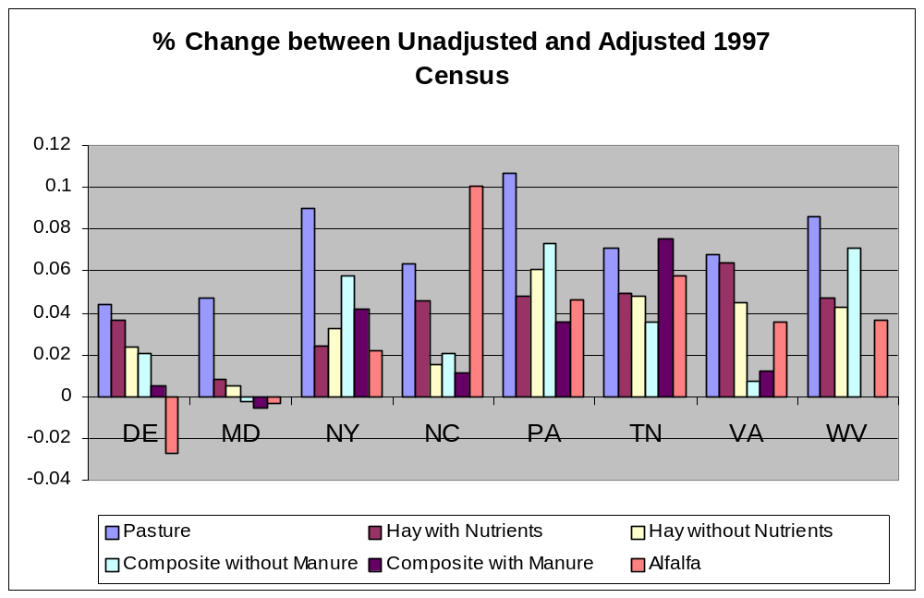
Figure 4.3. Relative change in agricultural land uses when the 2002 Agricultural Census methods were applied to the 1997 Agricultural Census data.

4.3.5.2 Adjustment of 1992–1982 Tables
Coverage adjustments for the 1982, 1987, and 1992 Censuses based on published census data are unavailable. To adjust these years, the percent change between the unadjusted 1997 Census and the coverage adjusted 1997 Census for each of the Phase 5 agricultural categories in each county was calculated. This percent change was applied to the acreage of each Phase 5 agricultural category in 1982, 1987, and 1992 to get the coverage-adjusted acreage for these years. The percent change used for each category in each state is presented in Table 4.4. Because of changes in census reporting, nursery and idle cropland were not reported in the 2002 Census. Consequently, a coverage adjustment could not be calculated for these two crops. For these two crops, the crop acreage was left unadjusted.

4.3.6 Incorporation of Agricultural Census into RESAC

4.3.6.1 County Data 2000 and 1990 Land Use
Agricultural census data were incorporated into RESAC land cover data to obtain acreage of specific crops on a county-segment scale. Adjustments were first made on a county basis. The county acreage was later parsed out to land-river segments to link the land simulation to the river simulation. Total agricultural land was calculated from the census as follows:
Total ag = (Total cropland) + (Pastureland, all types) – (Cropland used only for pasture or grazing)
Total agriculture from the agricultural census was interpolated to the land use base years of 2000 and 1990 using a linear regression of all five census years. For the 2000 and 1990 land use, total agriculture from the agricultural census is substituted in for the RESAC estimate of total agriculture, on a county scale. Total agriculture was then parsed into individual Phase 5 crops on the basis of the average ratio of crops in the agricultural census.

4.3.6.2 Field-Edge Land Use Class Accuracy Analysis
Inaccuracies in satellite data frequently occur around the borders of land use classes. An analysis of the satellite data identified the acreage of each type of land use within 1 pixel (30 meters) of the edge of an agricultural area. Assuming that the satellite will most frequently mislabel a pixel with the land use of an adjacent pixel, the proportional acreage of each land use surrounding an agricultural area represents the probability that agriculture was spectrally confused with that other land use. Analysis of the probability of confusion of the border pixels is called a Field-Edge Land Use Class Accuracy Analysis.
To keep the total county area fixed after the substitution of agricultural census into the 2000 satellite data, other land use classes needed to be adjusted. Other land use classes were adjusted in proportion to the probability that they were spectrally confused with agriculture, as calculated by an Edge of Field Land Use Class Accuracy Analysis.
In cases where total agriculture from RESAC was greater than in the census, the difference between the two was added to the remaining land uses (forest, woodlots, and wooded and low- intensity developed) in proportion to the amount of spectral confusion of each, as determined by the edge analysis. In cases where total agriculture from RESAC was less than total agriculture in the census, the difference between the two was subtracted from the remaining land uses proportional to the amount of spectral confusion.

4.3.7 Distribution of Land Use to Model Segments
After land use for each county was calculated, the aggregate county acreages for developed and agriculture were parsed out to individual land-river segments for model input. Acreage for high-density development and the portion of low-density development, which is fixed, were obtained from the 2000 RESAC product. County-level, total agricultural acreage from the agricultural census were parsed into land-river segments in proportion to the agricultural acreage in the satellite data. Individual agricultural categories within a land-river segment are determined by the ratio of census agricultural classes for that county. Remaining land uses are distributed into the remaining land-river segment area proportional to their acreage in the county.

4.3.8 Interpolation to Other Years
For each segment, the difference between the total county area and the sum of total agriculture and total developed were parsed to all other land uses proportional to their ratio within the county in the 2000 land use. Neither satellite data nor developed acreage are available for 1982, 1987, 1992, 1997, or 2002. The extent of the developed land uses was linearly extrapolated or interpolated to all years from the base 2000 and 1990 data. The linear interpolation of the agricultural census data were used to determine total agriculture. County acreage was parsed out to land/river model segments in the same manner as in 2000. Other land uses were determined by distributing the difference between the total county area and the sum of the agriculture and developed, in the same manner as the 1990 land use. In several cases (see Table 4.5), this methodology led to agricultural land acreage exceeding the total area of a land-river segment. In these cases, the agricultural acreage for that segment was set to 90 percent of the total county acreage, and the remaining land uses were distributed as described above.
Table 4.5. Land-river segments in which distributed agricultural area exceeded
land-river segment area
FIPS | CATCODE | County name | State | Year
A24035 | EU0_4475_0000 | Queen Anne’s | MD | 1987, 1992, 1997
A42013 | SJ2_2570_2660 | Blair | PA | 1987
B42041 | SL4_2370_2330 | Cumberland | PA | 1982, 1987
A42055 | PU3_3390_3730 | Franklin | PA | 1987
A42093 | SW7_1460_1640 | Montour | PA | 1982
A51015 | PS3_5990_6161 | Augusta | VA | 1982
A51121 | NR3_8430_7820 | Montgomery | VA | 1982, 1987, 1992
A51157 | RU3_5610_3460 | Rappahannock | VA | 1982, 1987, 1992
A51165 | PS0_6160_6161 | Rockingham | VA | 1982

4.4 Development of the Forest, Woodlots, and Wooded and Harvested Forest Land Uses

4.4.1 Forest, Woodlots, and Wooded
The Phase 5 forest, woodlots, and wooded land use includes woodlands, woodlots, and usually any wooded area of 30 meters by 30 meters remotely sensed by spectral analysis. The forest, wood lots, and wooded land use is the predominant land use in the Chesapeake watershed. Without the detail of separate wetland categories in Phase 5, the most representative land use category to include forested and emergent nontidal wetlands was in the forest, woodlots, and wooded land use. Accordingly, the low-loading, low-nutrient input land use of wetlands were included in this land use. For computational reasons, tidal wetlands were considered to be part of the domain of the tidal Chesapeake Bay WQSTM.

4.4.2 Harvested Forest
The Phase 5 harvested forest area is estimated to be about 0.33 percent of the forest, woodlot, and wooded land use everywhere in the Phase 5 domain. The period of time the disturbed forest exports high sediment loads is another problem for the HSPF structure. The literature suggests that a return to sediment export rates of undisturbed forest occurs after about 3 to 5 years (Arthur et al. 1998; Castro et al. 1997; Wang et al. 2003; Riekerk et al. 1998). With only two wooded land uses of forest, woodlot, and wooded and harvested forest, simulating the slow return of nutrient exports to the undisturbed forest rate is impractical, and simplifying assumptions have to be made. Accordingly, the harvested forest sediment export rates are applied in the simulation of the harvested forest area for 3 years, including the first year of forest harvesting, and in subsequent years revert to an undisturbed forest rate of sediment export. To account for the total land use of both harvested forest and land recovering from harvested forest land use, a total of 1 percent of land was set in harvested forest.
Another forest disturbance that reduces forest cover and increases runoff and erosion is fire, which can also be included in this land use category to the degree the available data on the amount of land involved allow.

4.5 Development of Extractive–Active and Abandoned Mines, Bare–Construction, and Other Minor Land Uses

4.5.1 Bare-Construction
Bare ground is considered to be a land cover because of construction. In the RESAC data, bare ground adjacent to the Chesapeake shoreline is likely to be sand, which is spectrally confused with bare earth. Consequently, the bare ground adjacent to the shoreline was removed from the RESAC bare ground land use and placed in the open water land use, which it resembles with respect to nutrient loading.
Bare-construction is an important land use because of its high sediment-loading capacity. The bare land category from RESAC included construction land, exposed rocks, and beaches. Data in this category was spectrally confused with extractive, developed, and agricultural land and was unsuitable as a proxy for construction acres. In each land-river segment, the RESAC bare land was eliminated, and the acreage that was bare land was put back into other RESAC classes in the proportion that they are present in the segment. Because bare land use had a very small acreage, the resulting increases in other land uses were minimal.
There is very little data available for yearly construction acreage on a state or county level. To obtain the bare-construction land use, the difference between the impervious land from the RESAC impervious estimates of 1990 and 2000 was used. The amount of impervious land, which increased over the 10-year period was assumed to have been through a transition to a bare-construction land use (Figure 4.4).

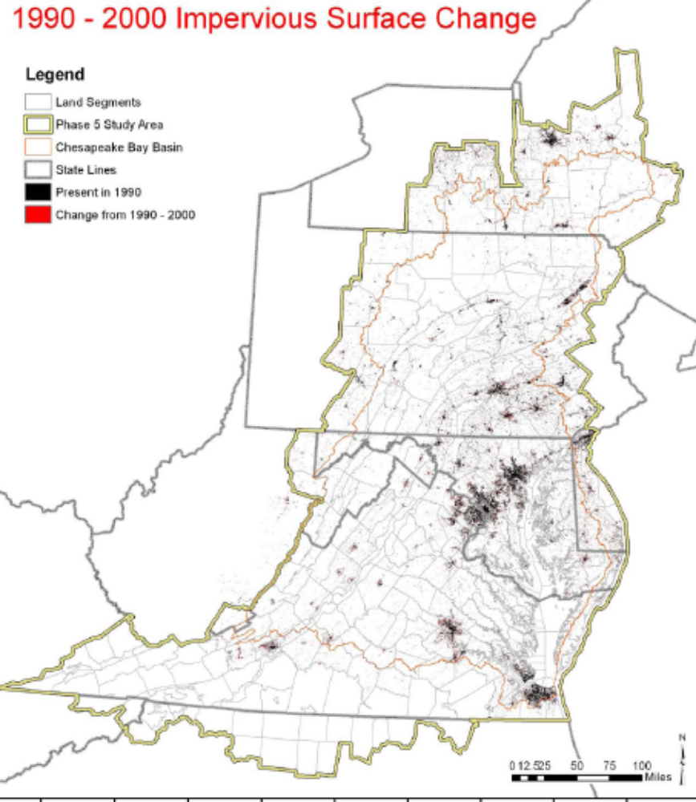
Figure 4.4. Change in impervious area from 1990 to 2000

The average yearly change in impervious surface in a segment is a good relative estimate of construction; however, it underestimates the area cleared by construction. Generally during the construction phase, more acres of land are cleared than end up as impervious surface and contribute to the sediment load from the construction area. Detailed records from all Maryland counties indicate that, on average, a unit area of imperviousness is generated from a construction permit covering about 10 times that impervious area, but that the area cleared for construction was 2.5 times the impervious area, or on average one-quarter of the total area of the site covered by the construction permit. Accordingly, the average yearly change in impervious surface was multiplied by 2.5 to calculate the Phase 5 bare-construction acreage. Although this calculation is static and does not reflect year-to-year changes in construction, it provides a uniform methodology for the entire Phase 5 study area.
Maryland permit data are available for state totals for the years 1998, 1999, 2001, 2002, 2003, and 2004. Phase 5 bare-construction area annual estimates for Maryland (here multiplied by a factor of four for consistency with total permitted construction acres as described above) fall within these reported values (Figure 4.5).
For 2000, construction was added into the land use after the adjustment was made for the agricultural census. To keep the total area fixed, the acres of construction were taken from forest and extractive in the proportion that they are present in the land river segment. In other land use years, construction was considered a fixed land use with agriculture and developed, and the remaining area in a land-river segment was parsed as described in Section 4.3.7.
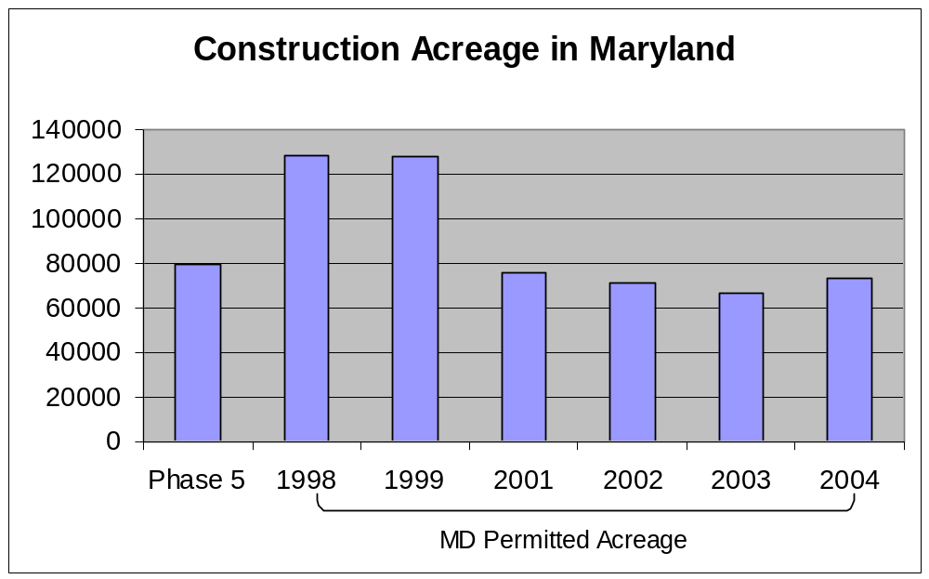
Figure 4.5. Permitted construction area in Maryland for 1998 to 2004 compared to the Phase 5 annual average bare-construction (bare-construction multiplied by a factor of four as described in the text) area.

4.5.2 Extractive-Active and Abandoned Mines
The extractive-active and abandoned mines land use is composed of mines, gravel pits, and the like. Federal and state laws in the early 1980s regulated active working mines and applied effluent limits of about 70 mg/L total suspended solids from mine effluent. Abandoned mines have, of course, no effluent limits. Consistent with the level of information available, extractive land south of the confluence of the West Branch and Susquehanna Rivers was considered to be active mines with an effluent limit applied (Don Fiesta, Pennsylvania Department of Environmental Protection, Bureau of Water Quality Protection, personal communication, August 9, 2004).
For 15 Virginia counties, permit data were available for active and unreclaimed mining acreage (not including sand and gravel pits). In many of these counties, RESAC underestimated the extractive acreage. For these counties, extractive acreage was calculated as the sum of active mining and unreclaimed mining acreage from Virginia permits. In all other Phase 5 counties, extractive acreage from RESAC was used.

4.5.3 Open Water
Open water area was estimated directly from the 2000 RESAC land use data. Tidal water is outside the Phase 5 domain, so only nontidal waters were quantified as the Phase 5 open water land use. The tidal and nontidal waters were differentiated by applying a NOAA high-resolution shoreline of tidal waters (NOAA 1994). Unlike other Phase 5 land uses, open water land use has a constant area and is unchanged over the 1985 to 2005 simulation period.

4.5.4 MS4 Areas
Developed areas that are part of Municipal Separate Storm Sewer Systems (MS4s) are tracked separately in the Phase 5 model. An MS4 area in the Phase 5 model is assumed to be an area under specific storm water regulations administered by the states. MS4s are a regulated discharge of stormwater. The first phase of the program (Phase I) required certain industrial dischargers, medium and large municipal separate storm sewer systems (MS4s), and operators of construction sites greater than five acres to obtain National Pollutant Discharge Elimination System (NPDES) permits. Medium municipal separate storm sewer systems are associated with municipalities with a population of 100,000 to 249,999 and large MS4s with a population of 250,000 or more. All other MS4s are considered small MS4s and are regulated in the Phase 2 MS4 program (USEPA 2000).
The estimated MS4 areas were provided by each of the Chesapeake Watershed states and represent the best current understanding of MS4 areas. While the best and final definition of an MS4 is delineated sewersheds, most jurisdictions can provide only municipal boundaries as an estimated MS4 area. Only the developed land is differentiated as being a contributor to the Stormwater load in a simulated Phase 5 MS4 area. If the developed land is within or without an MS4 area, the developed land was simulated the same and is differentiated only as a load contributing to an MS4 area or not.

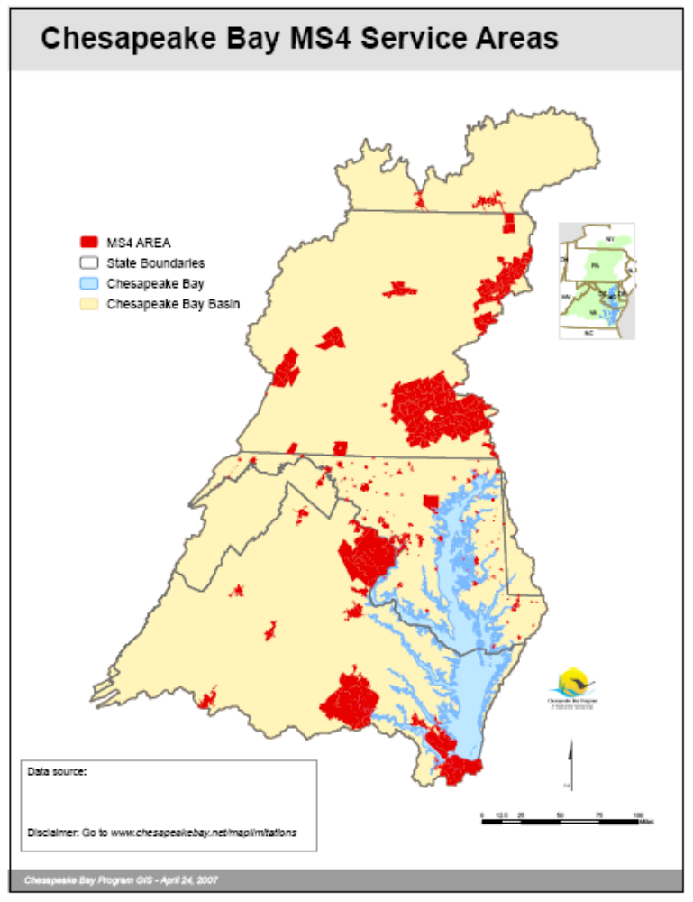
Figure 4.6. MS4 Areas in the Chesapeake Watershed.

4.6 Final Land Use For the Phase 5 Simulation Period of 1985 - 2005
A comparison of the Phase 4.3 and Phase 5 land use categories is in Table 4.6. Phase 5 expanded many of the land uses in Phase 4.3. For example, both Phase 4.3 and Phase 5 have the forest, woodlots, and wooded land use, but only Phase 5 has the land use of harvested forest. In the case of Phase 4.3 the assumption was that the harvested forest portion was generally represented within the overall forest, woodlots and wooded land use. Figures 4.7 to 4.19 graphically depict the Phase 5 land use and segmentation.

Table 4.6. Major land use/land cover types in the watershed model comparing
Phase 5 to Phase 4.3 version.
Model Land Uses | Phase 4.3 | Phase 5
Forest
Forest, Woodlots, & Wooded | √ | √
Harvested Forest |  | √
Agriculture
Conventional Tillage Receiving Manure | √ | √
Conventional Tillage Not Receiving Manure |  | √
Conservation Tillage  Receiving Manure | √ | √
Hay Land | √ | √
Alfalfa | √ | √
Hay With Nutrients |  | √
Hay w/o Nutrients |  | √
Pasture | √ | √
Nursery |  | √
Developed Land
Pervious | √
Impervious | √
Mixed Open | √
Low-Intensity Developed Pervious |  | √
Low-Intensity Developed Impervious |  | √
High-Intensity Developed Pervious |  | √
High-Intensity Developed Impervious |  | √

4.7 Estimates of Future Land Use In the Chesapeake Bay Watershed
4.7.1 Motivations for Developing Future Land Use Estimates
A major challenge facing water resource managers today is how to maintain progress restoring the Chesapeake Bay in the face of continued population and urban growth. The Chesapeake Bay Land Change Model (CBLCM) was developed to help address this management challenge. In conjunction with the Phase 5, the CBLCM can be used to assess potential future changes in nutrient and sediment loads to the Bay.

4.7.2 Scale of CBLCM Future Land Use Estimates
To meet the data requirements of Phase 5, the CBLCM forecasts change at the watershed modeling segment scale. The latest version of the CBLCM includes over 2,000 modeling segments (e.g., polygons) within the Bay watershed and intersecting counties. These segments were created based on an intersection of county boundaries, major topographic divides, and a 1:250,000 scale river reach drainage area network. Because the modeling segments are nested within counties, all data generated at the modeling segment scale can also be provided at the county scale for local review and comment.

4.7.3 Components of CBLCM Future Land Use Estimates
In support of the CBP management concerns, researchers from the US Geological Survey, US Environmental Protection Agency, Shippensburg University, and a private consultant developed the CBLCM which combines the strengths of a growth allocation model, GAMe (Reilly, 2003), with those of a cellular automata model, SLEUTH (slope, land use, excluded land, urban extent, transportation, and hillshade) (Clarke, et al., 1997; Jantz et al., 2003). The GAMe model projects future urban area at the watershed modeling segment scale by fitting total housing unit trends over the 1990’s to a

Gompertz (exponential “S”-shaped) curve which is then used to extrapolate housing trends to the year 2030. County population projections1 converted to County scale estimates of total housing demand are used to constrain the modeling segment scale forecasts generated using the Gompertz Curve. After the model segment scale forecasts of housing demand are adjusted to match the County scale housing demand totals, they are converted to an estimate of future urban area using segment specific ratios of urban land cover area to total housing units.

The proportions of urban growth occurring on farmland, forest land, sewer, septic, and within existing urban boundaries are determined uniquely for each watershed modeling segment using the SLEUTH urban growth model, a stochastic cellular automata model customized for application in the Chesapeake Bay watershed by Goetz and Jantz (2006). SLEUTH extrapolates historic rates and patterns of urban growth into the future using satellite derived imagery of 1990 and 2000 impervious cover. SLEUTH was calibrated separately in fifteen different County-clusters in the Bay watershed. Counties were clustered together based on shared characteristics of urban growth, commuting patterns, and state and ecoregion boundaries. SLEUTH uses a Monte Carlo method to generate multiple simulations of future growth which are combined to create a probability map of future urban development. The output from SLEUTH is a 30m-resolution probability raster dataset that indicates the probability of urban growth in the year 2030 with values ranging from 0 to 100 percent.

The patterns of probable growth may vary for each cluster of counties based on the coefficients used to calibrate SLEUTH in each cluster. The patterns and levels of probable urban growth may also vary within a county based on local factors of attraction and repulsion. These factors are represented in a 30m-resolution raster dataset referred to as an “exclusion layer”. Local areas “off limits” to development may include public lands, conservation easements, rurally zoned lands, steep slopes (greater than 21% grade), emergent wetlands, and open water. For the Bay watershed, an exclusion layer was created in a GIS using information on public and protected lands, generalized zoning, and land cover. Values greater than 50 are relatively repulsive to growth with 100 being completely excluded. Values less than 50 are relatively attractive to growth (e.g., areas zoned for moderate or high density growth). The mid-point, 50, is neutral.
The probability output from SLEUTH is overlaid onto a raster land cover dataset to determine the relative proportions of land cover classes and sewer areas impacted by future growth. For example, if a cell with a fifty-percent probability of becoming developed by 2030 overlays a forest cell in the land cover map, then fifty-percent of that quarter-acre cell is considered forest loss. For each modeling segment, the total acreage of all land cover classes converted to urban growth are summed and divided by the total amount of urban growth acreage forecasted in the modeling segment. This process generates relative proportions of future growth by land cover class for each modeling segment. Multiplying these proportions by the acreage of forecasted growth (generated by GAMe) determines how much acreage to subtract or add in future years to the Phase 5 watershed model 2002 baseline land use classes.

The CBLCM also includes a Sewer Model to estimate the population on sewer and septic in the years 2000 and 2030. Where local data was not available, a population density raster dataset derived from year 2000 Census Block Group data and detailed road vector files was used to represent probable sewered areas in the year 2000. This approach captures 81% of Maryland’s mapped residential sewered areas based on a one-to-one cell comparison. This approach also compares favorably with survey data in Virginia representing households with sewer service in the 2001 to 2005 time period.

Modeled sewered areas in the year 2000 were expanded along existing roads by 300m to 2000m to represent possible expansion of the sewer network through the year 2030. Forecasted population values for each watershed modeling segment were derived by converting the housing demand forecasts into estimates of future population. Future populations on sewer and septic were estimated by overlaying the SLEUTH probability map onto the modeled sewer service areas for 2030 to derive proportions of growth on sewer and septic which were then multiplied by the forecasted population in each modeling segment. The proportions of growth on sewer and septic were kept constant for all interim year forecasts between 2000 and 2030. The percent change in population within each sewer service area was used to estimate the percent change in flow for all wastewater treatment plants within and/or close to each service area.

4.7 Results of Future Land Use Estimates

7/21/08
NEED TO GET RID OF THE FOOT NOTE BELOW & GET REFERENCES FOR SECTION 4.7 FROM PETER

1 For the Bay watershed, county population projections out to the years 2010, 2020, and 2030 are supplied by state and regional government agencies.

References
Arthur, M.A., C.B. Coltharp, and D.L. Brown. 1998. Effects of best management practices on forest streamwater quality in Eastern Kentucky Journal of the American Water Resources Association 34:3 pp:481-495.

Castro, M. S., K.N. Eshleman, R.P. Morgan II, S.W. Seagle, R.H. Gardner, and L.F. Pitelka. 1997. Nitrogen dynamics in forested watersheds of the Chesapeake Bay STAC Report Number: 97-3 Scientific and Technical Advisory Committee, Frostburg, MD, June 1997.

CTIC (Conservation Technology Information Center). 1989-2004. National Crop Residue Management Survey. <www.ctic.purdue.edu/Core4/Core4Main.html>. Accessed August 24, 2007.
Goetz S.J., C.A. Jantz, S.D. Prince, A.J. Smith, R. Wright, and D. Varlyguin. 2004. Integrated analysis of ecosystem interactions with land use change: The Chesapeake Bay watershed. In Ecosystems and Land Use Change, eds. R. S. DeFries, G. P. Asner & R. A. Houghton) pp. 263-275. American Geophysical Union, Washington, DC. <ftp://ftp.whrc.org/Mid-Atlantic/GOETZ-PUBS/Goetz-2004-ChapmanBook.pdf>. Accessed August 23, 2007.
Homer, C., C. Huang, L. Yang, B. Wylie, and M. Coan. 2004. Development of a 2001 National Landcover Database for the United States. Photogrammetric Engineering and Remote Sensing 70(7):829–840. <http://www.mrlc.gov/pdfs/July_PERS.pdf>. Accessed August 24, 2007.

Homer, C., C. Huang, L. Yang, and B. Wylie. 2002. Development of a circa 2000 land cover database for the United States. In Proceedings of the 2002 ASPRS Annual Convention, April 2002, Washington, D.C. CD-ROM. American Society for Photogrammetry & Remote Sensing, Bethesda, Md. <http://landcover.usgs.gov/pdf/asprs_final.pdf>. Accessed August 23, 2007.

NOAA (National Oceanic and Atmospheric Administration). 1994. Medium Resolution Digital Vector Shoreline, 1:80,000. Digital Vector Shoreline data product generated by the Data Management and Geographic Information Systems Group of the Strategic Environmental Assessment Division, ORCA-NOS-NOAA <http://cammp.nos.noaa.gov/ORCAIIs/proddetails.taf?OFFERINGCODE=2_SEA_Shore lineData>. Accessed August 24, 2007.

Palace, M.W., Hannawald, J.E., Linker, L.C., Shenk, G.W., Storrick, J.M., and Clipper, M.L. (1998). “Chesapeake Bay Watershed Model Application and Calculation of Nutrient and Sediment Loadings - Appendix H: Tracking Best Management Practice Nutrient Reductions in the Chesapeake Bay Program”, EPA 903-R-98-009, CBP/TRS 201/98, U.S. Environmental Protection Agency Chesapeake Bay Program, Annapolis, MD.

Riekerk, H., D.G. Neary, and W.T. Swank. 1988. The magnitude of upland silviculture nonpoint source pollution in the South. Ed. Hook, Donald D.; Lea, Russ Conference on the Forested Wetlands of the Southern United States, Asheville, NC U.S. Department of Agriculture, Forest Service, Southeastern Forest Experiment Station pp: 8-18.

Tele Atlas. 2004. Dynamap® 2000 Road Network Database. <http://www.teleatlas.com/Pub/Products/Map_Databases/Dynamap/index.htm>. Accessed August 23, 2007.

U.S. Census Bureau. Economics and Statistics Administration. 1982. U.S. Department of Commerce. 1982 Census of Agriculture. (Geographic Area Series 1C). Government Printing Office, Washington, DC.
U.S. Census Bureau. Economics and Statistics Administration. 1987. U.S. Department of Commerce. 1987 Census of Agriculture. (Geographic Area Series 1C). Government Printing Office, Washington, DC.
U.S. Census Bureau. Economics and Statistics Administration. 1992. U.S. Department of Commerce. 1992 Census of Agriculture. (Geographic Area Series 1C). Government Printing Office, Washington, DC.
U.S. Census Bureau. Economics and Statistics Administration. 1997. U.S. Department of Commerce. 1997 Census of Agriculture. (Geographic Area Series 1C). Government Printing Office, Washington, DC.
U.S. Census Bureau. Economics and Statistics Administration. 2002. U.S. Department of Commerce. 2002 Census of Agriculture. (Geographic Area Series 1C). Government Printing Office, Washington, DC.
USEPA (U.S. Environmental Protection Agency). 2000. Stormwater Phase II Compliance Assistance Guide. Office of Water EPA 833-R-00-002. Washington, DC. <http://www.epa.gov/npdes/pubs/comguide.pdf>. Accessed August 23, 2007.
USGS (United Sates Geological Survey). 1992. National Land Cover Dataset 1992 (NLCD 1992). USGS Land Cover Institute, Reston, VA. <http://landcover.usgs.gov/natllandcover.php>. Accessed August 23, 2007.

Wang, P., L.C. Linker, and K.N. Eshleman. 2003. Dynamic parameterization to simulate DIN export due to gypsy moth defoliation, in International Conference on Computer Science, p. 30-38.

Cite as:
USEPA, (U.S. Environmental Protection Agency). 2009. Chesapeake Bay Phase 5 Community Watershed Model. In preparation EPA XXX-X-XX-008. U.S. Environmental Protection Agency, Chesapeake Bay Program Office, Annapolis MD. January 2009.

Revised October 24, 2008

NOTE: NEED New figures 4.9 to 4.21 FROM APPENDIX into the Last Section 4.5 and RENumber the figures as needed.

